Assignment 4

Name: Lukas Pfalz

ITS 1110

Section: CSC-1110-71762

# **Assignment 4**

***COMPLETE THE HONOR CODE BELOW***

**HONOR CODE:**

I pledge that this program represents my own program code, I have received help from no one and I have given help to no one.

**OR**

I received help from **NAME OR NO ONE** in designing and debugging my program.

I have given help to **NAME OR NO ONE** in designing and debugging my program.

I pledge that this program represents my own program code, I have received help from no one and I have given help to no one.

This assignment is required.

The grading form shows point values for this assignment. Please review it now.

Show screen shots of the python code with comments and your input/output window.

You should use several well-planned sets of data to check out your program. Testing your programs with just the data that is asked for in the assignment does not necessarily mean that the programs will work for all cases.

Please include the following comments in each of your Python programs:

Your Name

Section

Date

Description

Assignment Number

A python template (python_template.py) has been provided for you to use.

Name this document XXX_Assignment 4 where XXX are your initials. Include a python file named P01.py, P02.py, etc. for each problem.

## Write a program with only one loop that prints to the console the even numbers from 40 through 86 (40,42, 44 …78, 86). Show screen shots of the PYTHON program, all input and output. Save this program.

Output should look like this:

40

42

44

46

48

50

52

54

56

58

60

62

64

66

68

70

72

74

76

78

80

82

84

86

**PLACE SCREEN SHOTS OF THE PYTHON CODE AND ALL I/O BELOW.**

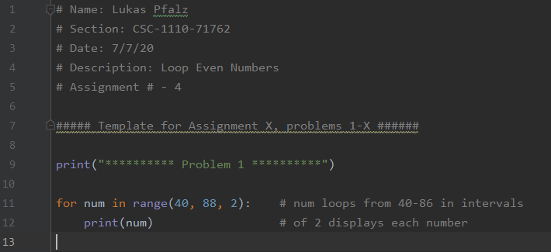

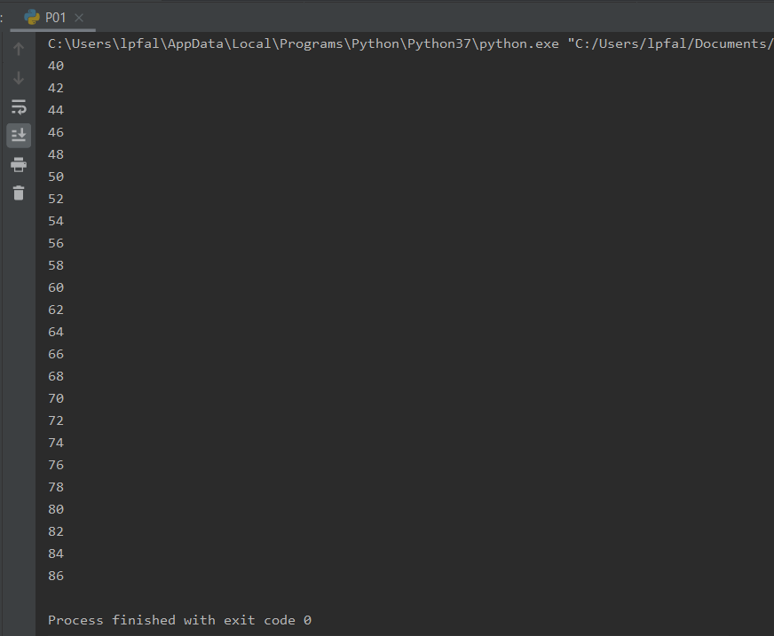

## Write a program to display the message "Hello, how are you!!" the number of times requested by the user. Your algorithm should accept an integer indicating how many times to display the message, then it should output how many times you asked the phrase to be output and then output the message to the that number of times.

Here's a sample running of the program:

How many times should the output print?

5

You asked to have the output print 5 times.

Hello, how are you!!

Hello, how are you!!

Hello, how are you!!

Hello, how are you!!

Hello, how are you!!

Comment your source code and describe your code to someone who may be viewing it for the first time.

**PLACE SCREEN SHOTS OF THE PYTHON CODE AND ALL I/O BELOW.**

## 

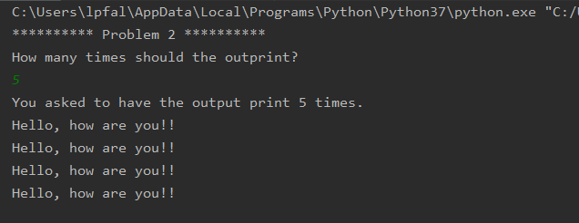

## Write a program that uses a loop with a sentinel value to find the sum of the values input. Prompt user to input the values until a sentinel value of -999 is input. After the sentinel value is input, output the sum. Input the following numbers 21, -147, 77, 81, 1002, -23 and -999.

An example of an output results as follows:

Enter your number: 2

Enter your number: 3

Enter your number: 4

Enter your number: -999

The sum is 9

Comment your source code and describe your code to someone who may be viewing it for the first time.

**PLACE SCREEN SHOTS OF THE PYTHON CODE AND ALL I/O BELOW.**

